**CHAPTER 6**

**RESULT**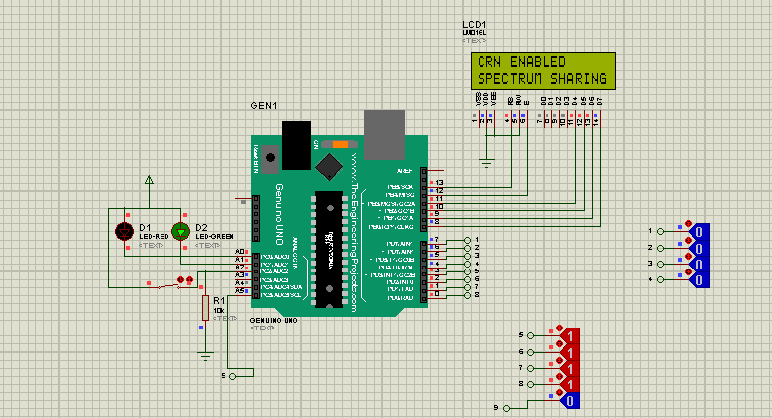

**Figure 6.1 Simulation Output**

**Software used:**

Proteus 17.2

Arduino IDE

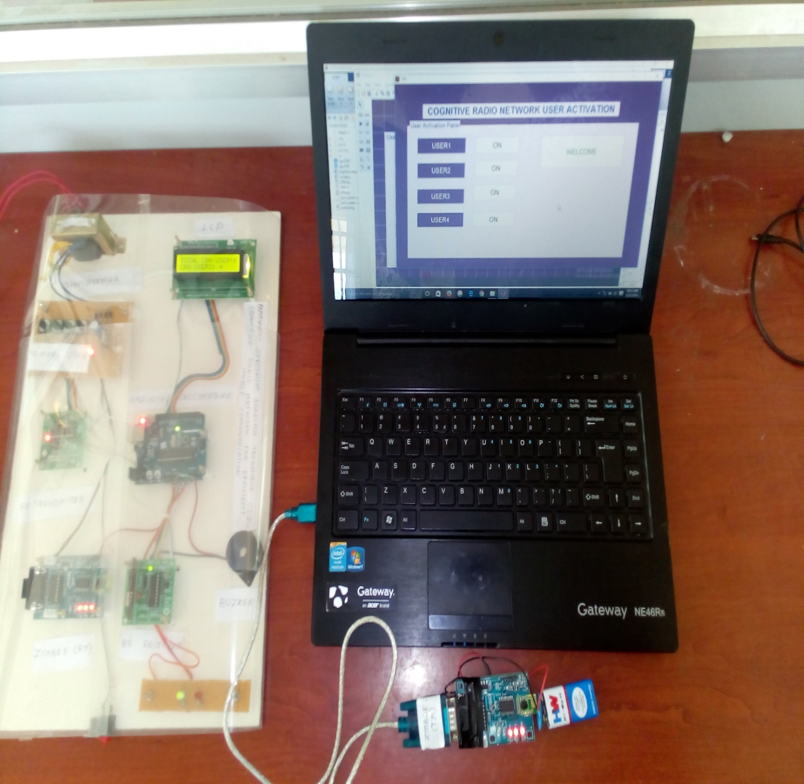

**Figure 6.2 Hardware Result**

* At Normal Mode, the primary and secondary users calls are connected using their respective spectrum
* When spectrum is overloaded, the Buzzer will be ON and then CRN mode is activated
* At CRN Mode, When primary spectrum is overloaded the call is automatically connected to another free spectrum